CHAPTER 9: Energy transmission
Worksheet 9.5

The eye
Science Quest 9: pages 320–5
Student: Class:

The structure of the eye
1. (a) Identify each of the structures labeled U–Z in the diagram of the eye below.
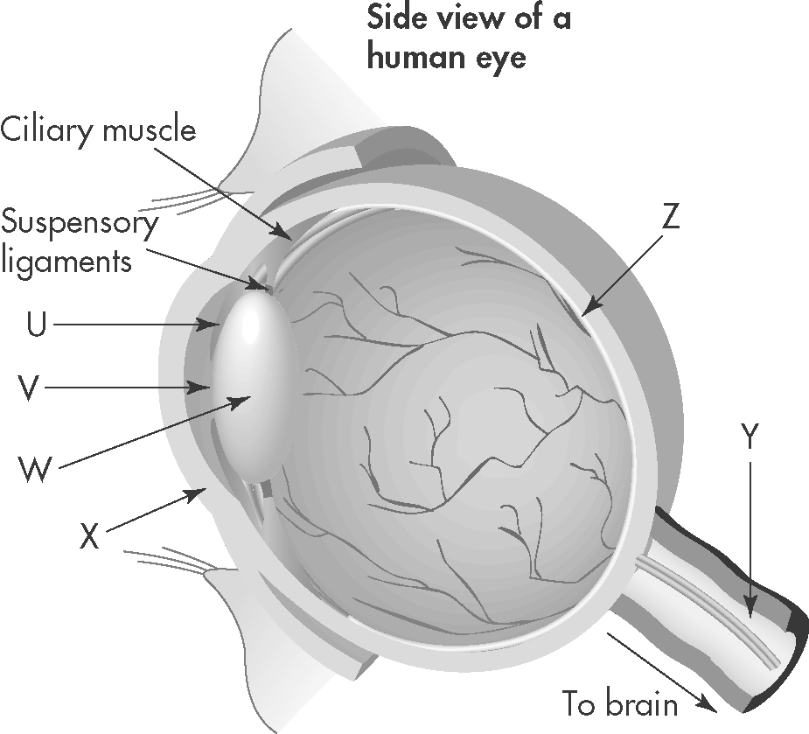 | U: .......................................................  V: ........................................................  W: .......................................................  X: ........................................................  Y: ........................................................  Z: .........................................................
(b) Identify the structure of the eye that matches each of the following descriptions:
A. Bends the incoming light, so that it passes through the pupil towards the lens.
B. The image forms here. The light-sensitive cells detect the brightness and colour of the different parts of the image.
C. The opening through which light travels towards the lens.
A: | B: | C:

Correcting vision
2. Long-sightedness can be corrected using a suitable lens. Without a corrective lens the image of an object is blurred.
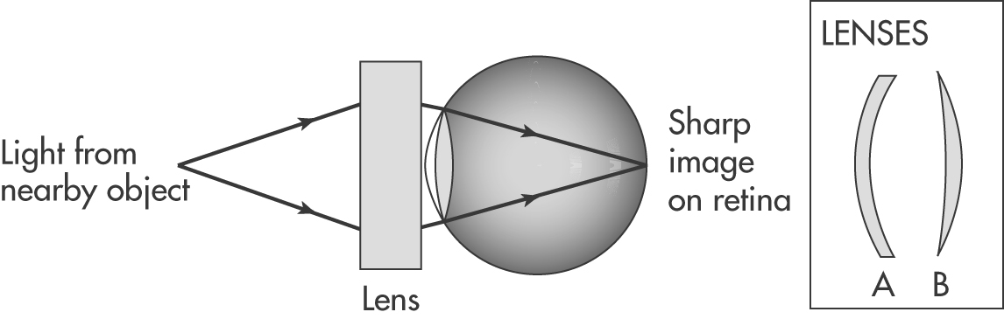
(a) Identify which lens (A or B) will be suitable to correct hyperopia (long-sightedness).

(b) Where will the image form if this corrective lens is not used?

CHAPTER 9: Energy transmission
Worksheet 9.5

Page 2

Focussing on light
3. Thin beams of light are projected from a ray box towards four objects. Each object is covered by a tile. The beams emerging from each of the objects are shown in the diagrams below. Name or describe the object under each tile.

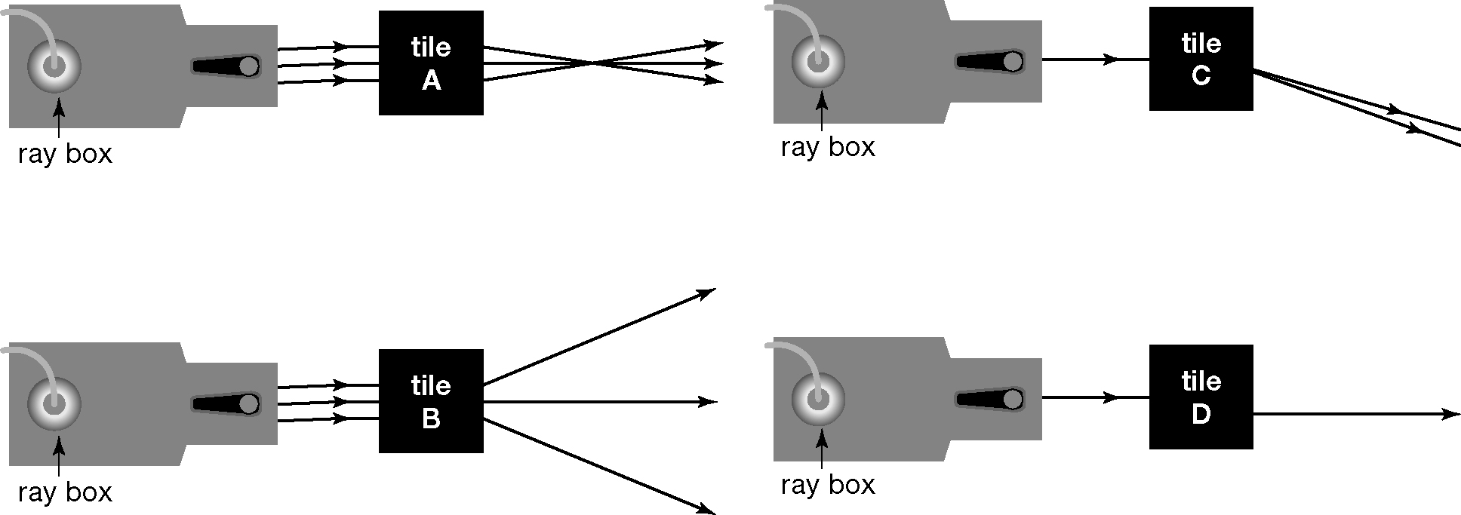

4. Did you know that your eyes have a blind spot? We do not normally notice that we have a blind spot as our brain merges the two images we get, one from each eye. Our brains are also very clever and they can fill in some of the gaps for us. In the area where the optic nerve meets the retina, there are no rods or cones to detect light. Therefore, if light from an object is focused onto this part of the retina, we cannot see it.
See for yourself!
1. Hold this page about an arm’s length from your face.
2. Cover your right eye with your hand.
3. Stare at the dot below. You will be able to see the ‘X’ out of the corner of your eye, but keep looking at the dot.
 
4. Slowly move the page towards you. Keep looking at the dot. At some point the ‘X’ will disappear. This is your blind spot.
5. Now repeat steps 1–4 using the dot and cross with a line ruled through the middle. Remember to stare at the dot.
 
(a) Describe what happens this time. In particular, what changes do you notice along the line?

(b) Explain why this might happen.

